**Mini Project : Polygons**

**How to Input Data?**

**Manual Input**

1. You will be prompt to enter the number of sides of the polygons you want.
2. For every sides, the program will ask if you want to have it straight or curve
3. Then, you can insert the coordinates based on the prompt
   1. If you want straight, it might ask you for 2, 1, or 0 points based on the sides you are at now. If you are at the first side, it will ask for starting point and ending point of the particular sides. If you are at any of the middle sides, it will just ask for the next point. If you are at the last side, you will not be asked for any points.
   2. If you want curve, it might ask you for 4, 3, or 2 points based on the sides you are at now. If you are at the first side, it will ask for starting point and ending point as well as the two control points of the particular sides. If you are at any of the middle sides, it will ask for ending point and two control points of the particular sides. If you are at the last side, it will ask for two control points of the particular sides.
4. If you are sure of your inputs, you can continue it by saving the coordinates as file. If not then, you will be given the chance to choose your input mode.
5. For the file naming, just input the name without .txt extension.

**File Input**

1. You will be prompt to enter the file name, do not include the .txt extension. Just press enter if you want to exit.
2. The structure of the file is as follows

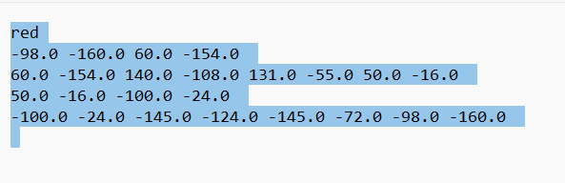

First line is only for color of the line you want. The following lines are the sides of the polygons. For straight sides, input coordinate of starting point then coordinate of ending point. For curve sides, input coordinate of starting point then coordinate of first control point then coordinate of second control point and then the coordinate of ending point. You can use integers or floats, it shouldn’t affect anything.

**Point and Click**

1. You will be prompt to enter the number of sides of the polygons you want.
2. For every sides, the program will ask if you want to have it straight or curve
3. If you want straight, click the starting point and ending point. If you want curve, click ending point followed by control point 1 and control point 2.
4. If you are sure of your inputs, you can continue it by saving the coordinates as file and choose the color of the line. If not then, you will be given the chance to choose your input mode.
5. For the file naming, just input the name without .txt extension.

**How to Transform?**

*Note: polygon defined by users are automatically centered to the origin by the program.*

There are 5 types of option:

**Pattern 1: Polygon is drawn in a n by n format:**

(*n=4 as an example*)

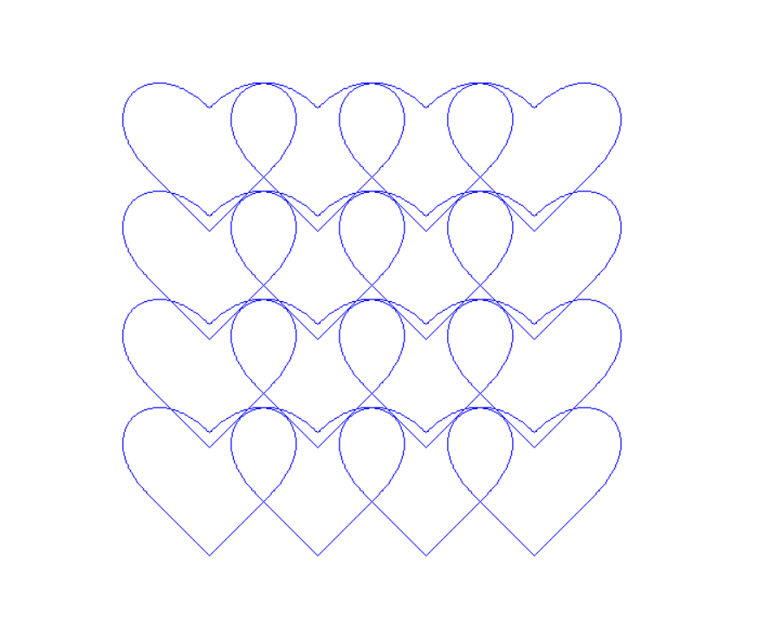 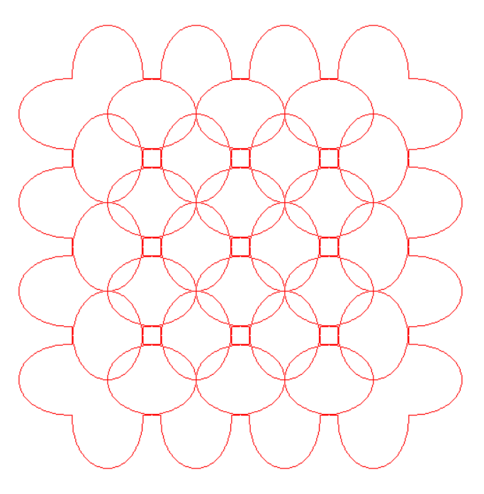

**Pattern 2: Polygon is drawn n times forming a circle around the origin**

(*n=7 as an example*)

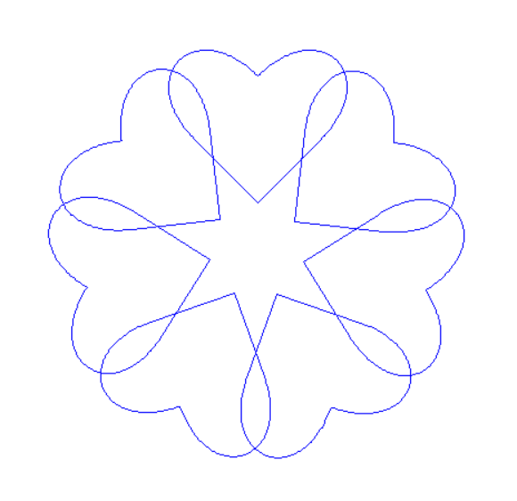 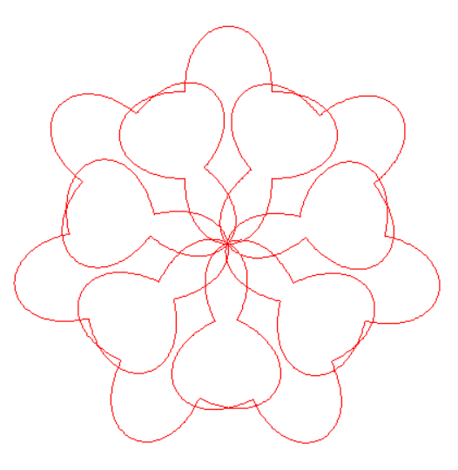

**Pattern 3: The polygon is enlarged n-1 times around the origin while getting rotated**

(*n=4, angle=30 as an example*)

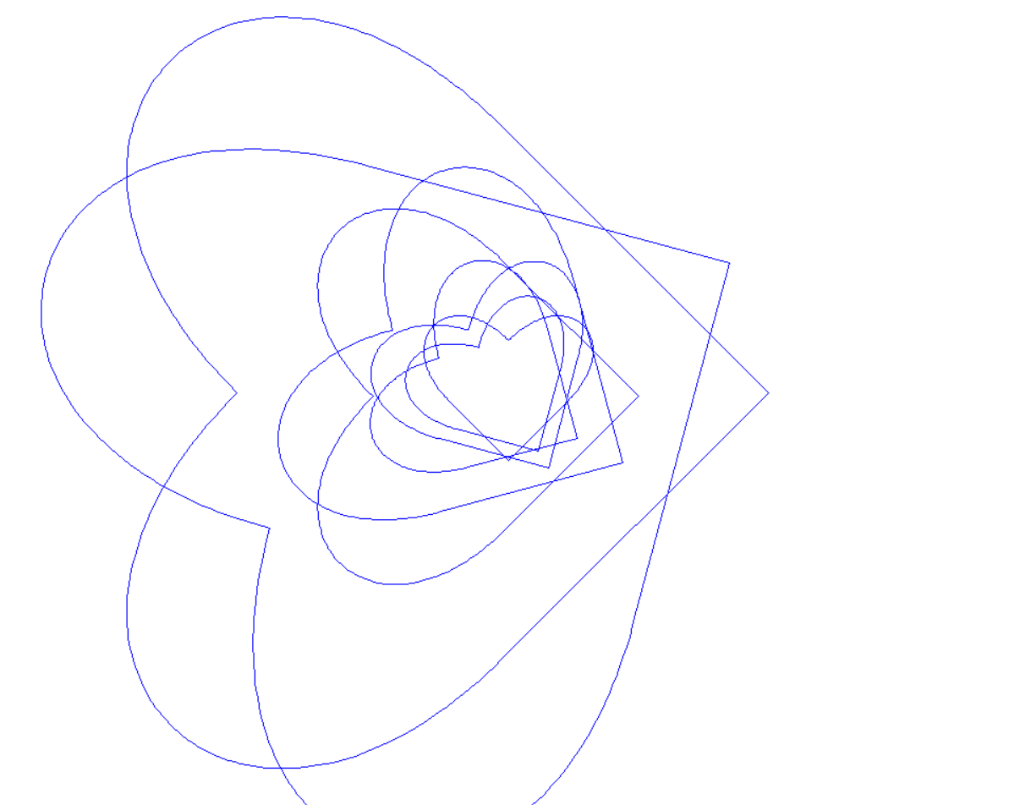 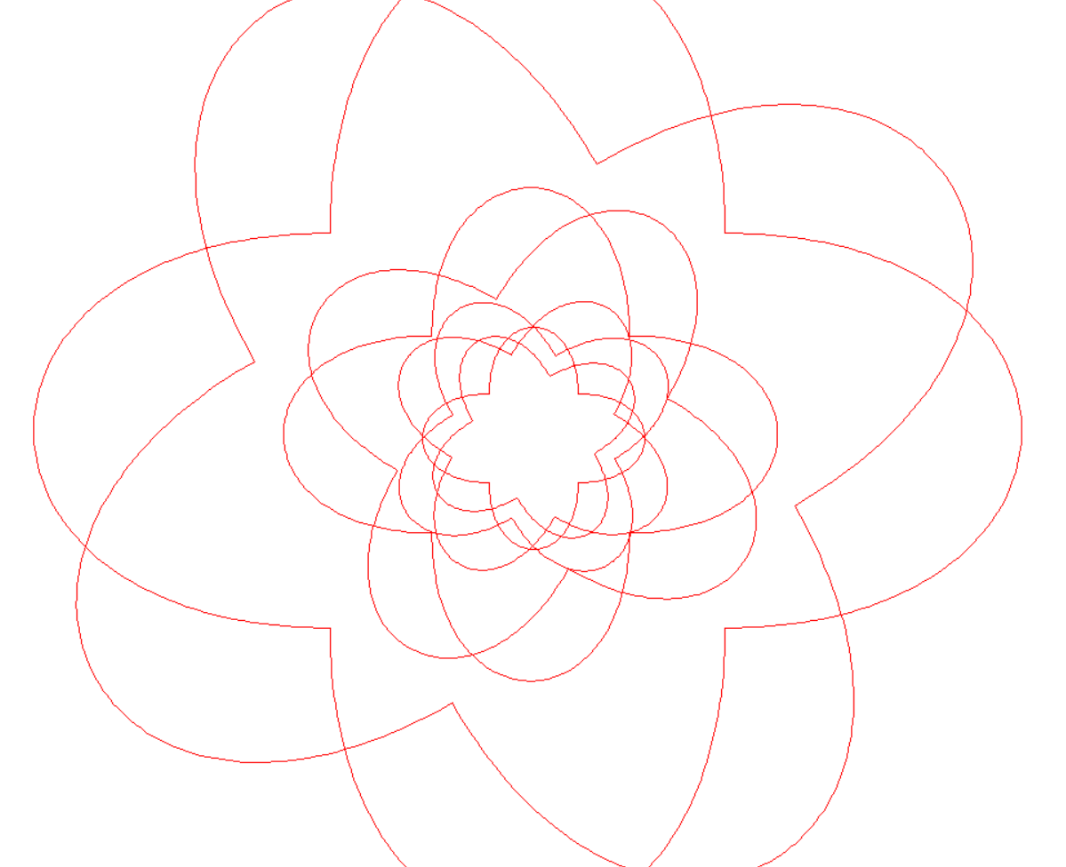

**Pattern 4: The polygon is sheared x and y from first point, then enlarged n-1 times and reflected to all** four quadrants. (*n = 4 as an example*)

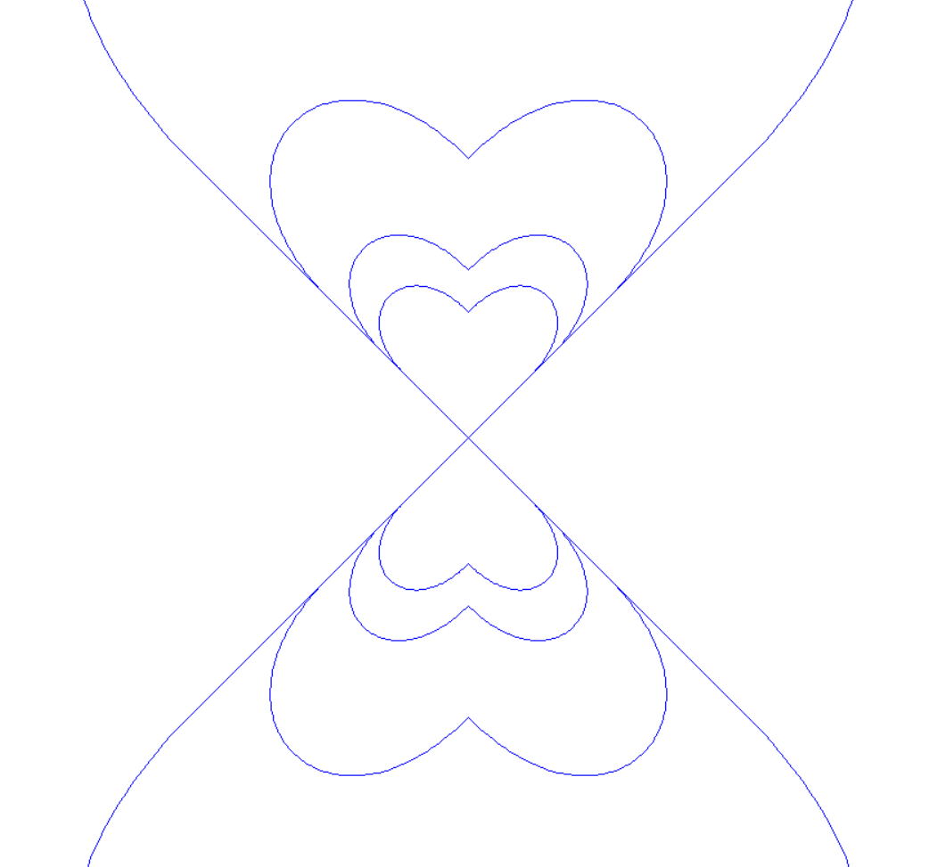 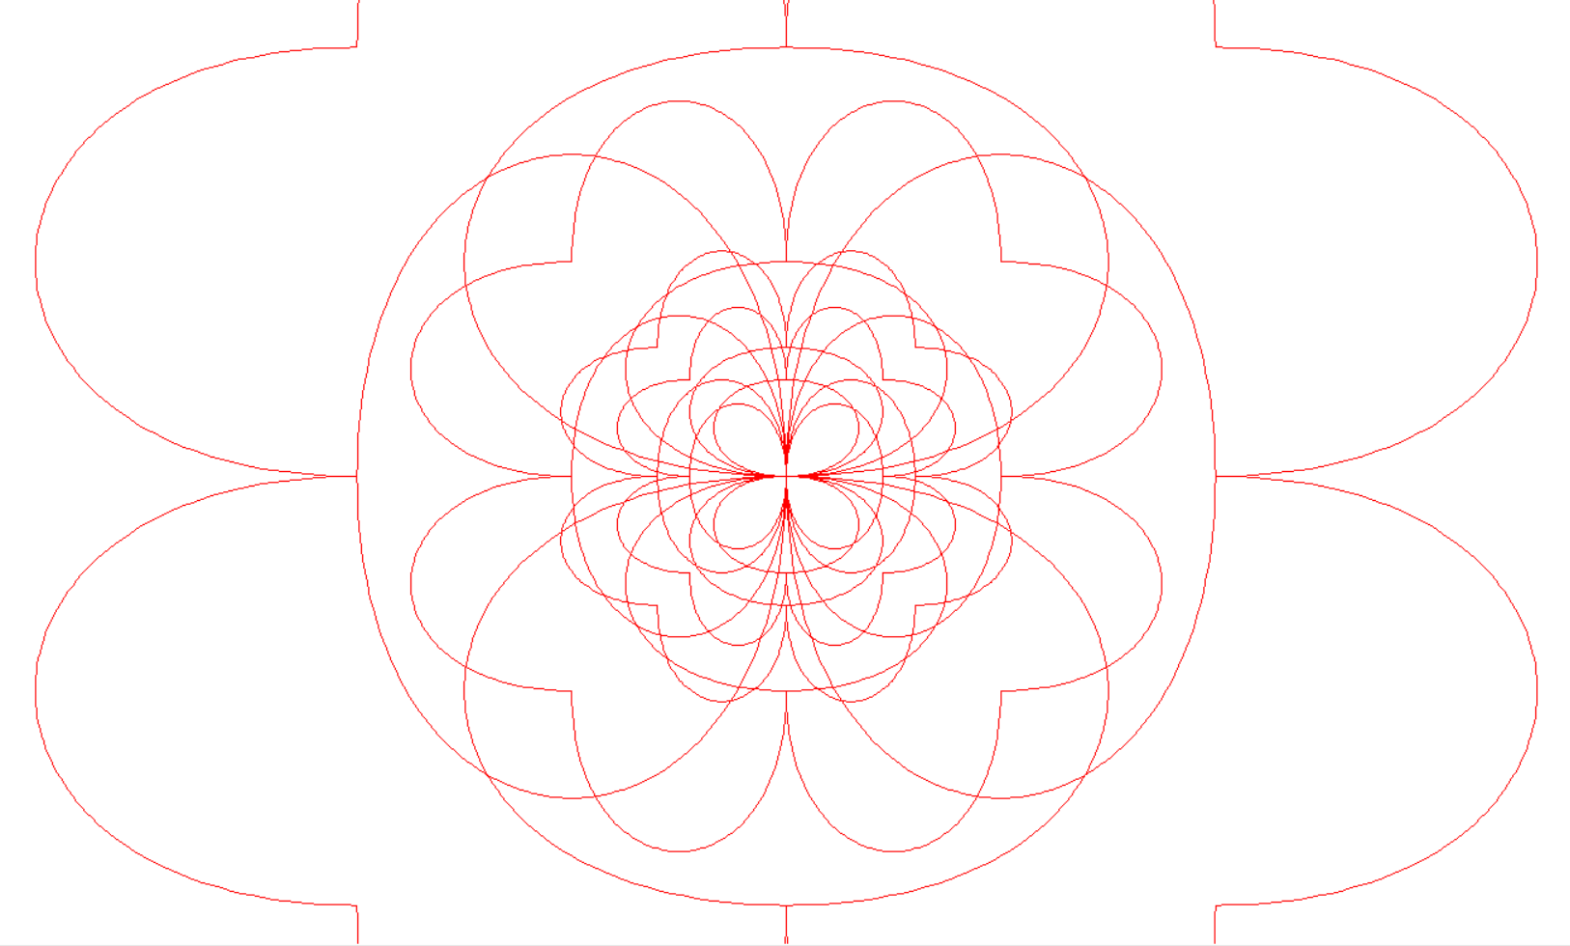

*(An example of pattern 1 and 2 together)*

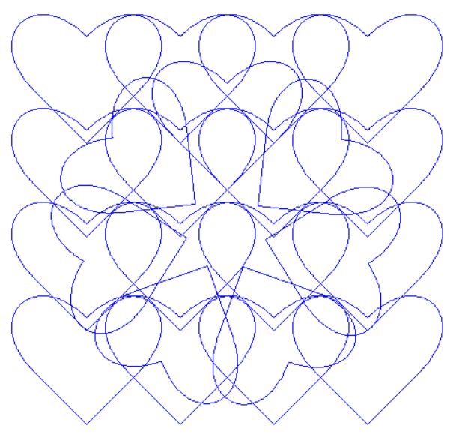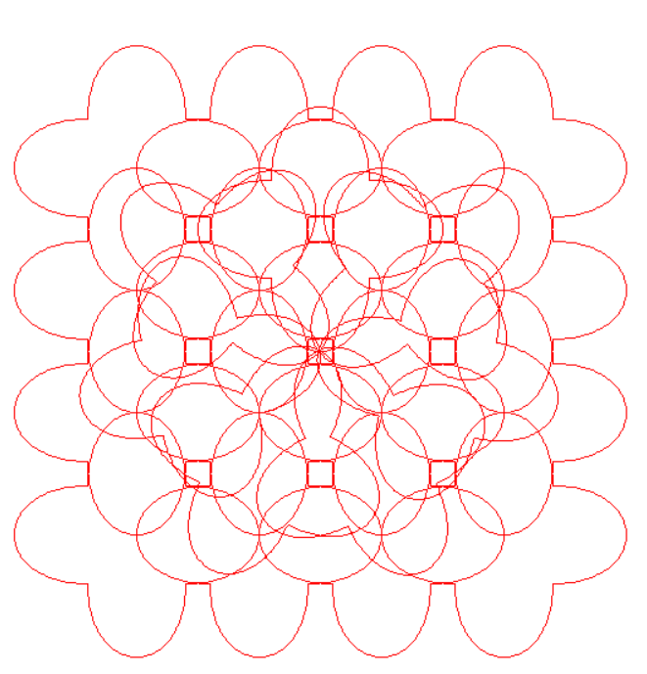

**Option 5: This is the option where you can do your own transformation**

There are a few options you can choose:

[0] : exit the program, which will give you chance to save the polygon as a file

[1] : translation

[2] : rotation

[3] : shearing

[4] : scaling

[5] : reflection

[6] : center in origin

[7] : show current polygon, means that show the last transformed polygon

[8] : reset to previous polygon, means “undo”

[9] : rest to original polygon, means “undo all the way to the beginning”

[10] : clear board

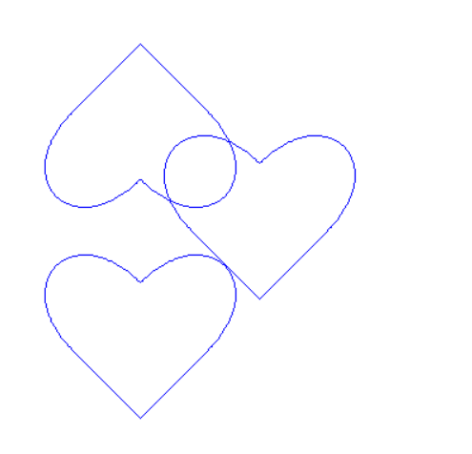

*(An example of translation, show current, reflection, show current) (Last polygon is the inverted heart)*

*Note: The transformation done is cumulative, so you can do translation then reflection of the results directly*

**Pros and Cons of The Program**

**Some cool features:**

1. Point and click feature allow users to input coordinates by just clicking the screen on turtle.
2. During manual input or point and click input, the dots will be shown as you input the points. Lines and curves will also be drawn during inputting. This makes it easier for user to visualize their polygon.
3. You can do your own transformation and make a new shape out of a basic shape and save it which can be used to do patterns.
4. Able to keep track of the transformed polygons in the Your Own Transformation section, which means can use undo and continue the transformation from last transformed polygon.

**Some cons:**

1. Need to type S or C to indicate straight or curve all the time during manual input or point and click.
2. Cannot exit immediately at any point of the program.
3. Patterns are not reusable